# Download Azure Powershell

Link, blah, blah

# Deploy

1. Login-AzureRmAccount
2. Select-AzureRmSubscription -SubscriptionID "bc4170f0-cc6e-49d2-ba65-bc00a7a4df6b"
3. New-AzureRmResourceGroup -Name rbaResourceGroup7 -Location "Central US"
4. New-AzureRmResourceGroupDeployment -Name rbaDeployment7 -ResourceGroupName rbaResourceGroup7 -TemplateFile "C:\Users\roalexan\Source\Repos\SolutionArchitects\Collateral\Gallery Samples\SQL Data Warehouse\deploy.json"
5. Start ASA job

TODO: Run SQL from Powershell

Open Microsoft SQL Server Management Studio

File > Connect Object Explorer

Server type: Database Engine

Server name: personal-rba4.database.windows.net

Authentication: SQL Server Authentication

Login: personaluser

Password: pass@word1

--SELECT * FROM information_schema.tables

--drop table events;

--drop table ratings;

CREATE TABLE Events (

EventId INT NOT NULL NOT NULL,

EventName VARCHAR(20) NOT NULL,

Speakers VARCHAR(200) NOT NULL,

Topics VARCHAR(200) NOT NULL,

Country VARCHAR(10) NOT NULL,

State VARCHAR(2) NOT NULL,

City VARCHAR(20) NOT NULL

)

WITH (

DISTRIBUTION = HASH(EventId),

CLUSTERED COLUMNSTORE INDEX

)

CREATE TABLE Ratings (

DateTime DATETIME NOT NULL,

EventId INT NOT NULL,

Rating INT NOT NULL

)

WITH (

DISTRIBUTION = HASH(DateTime),

CLUSTERED COLUMNSTORE INDEX

)

INSERT INTO Events VALUES(1,'MLADS','roalexan,jacrowle','sqldw,dl','USA','WA','Redmond')

INSERT INTO Events VALUES(2,'STRATA','roalexan,jacrowle','sqldw,dl','USA','WA','Redmond')

INSERT INTO Events VALUES(3,'BUILD','roalexan,jacrowle','sqldw,dl','USA','WA','Redmond')

INSERT INTO Events VALUES(4,'USER','roalexan,jacrowle','sqldw,dl','USA','WA','Redmond')

Strata

Spark

R

--INSERT INTO Ratings VALUES('2015-08-13 00:15:07',1234,5)

--INSERT INTO Ratings VALUES('2015-08-13 00:16:07',1234,1)

--INSERT INTO Ratings VALUES('2015-08-13 00:17:07',1234,3)

--select * from Events;

--select * from Ratings;

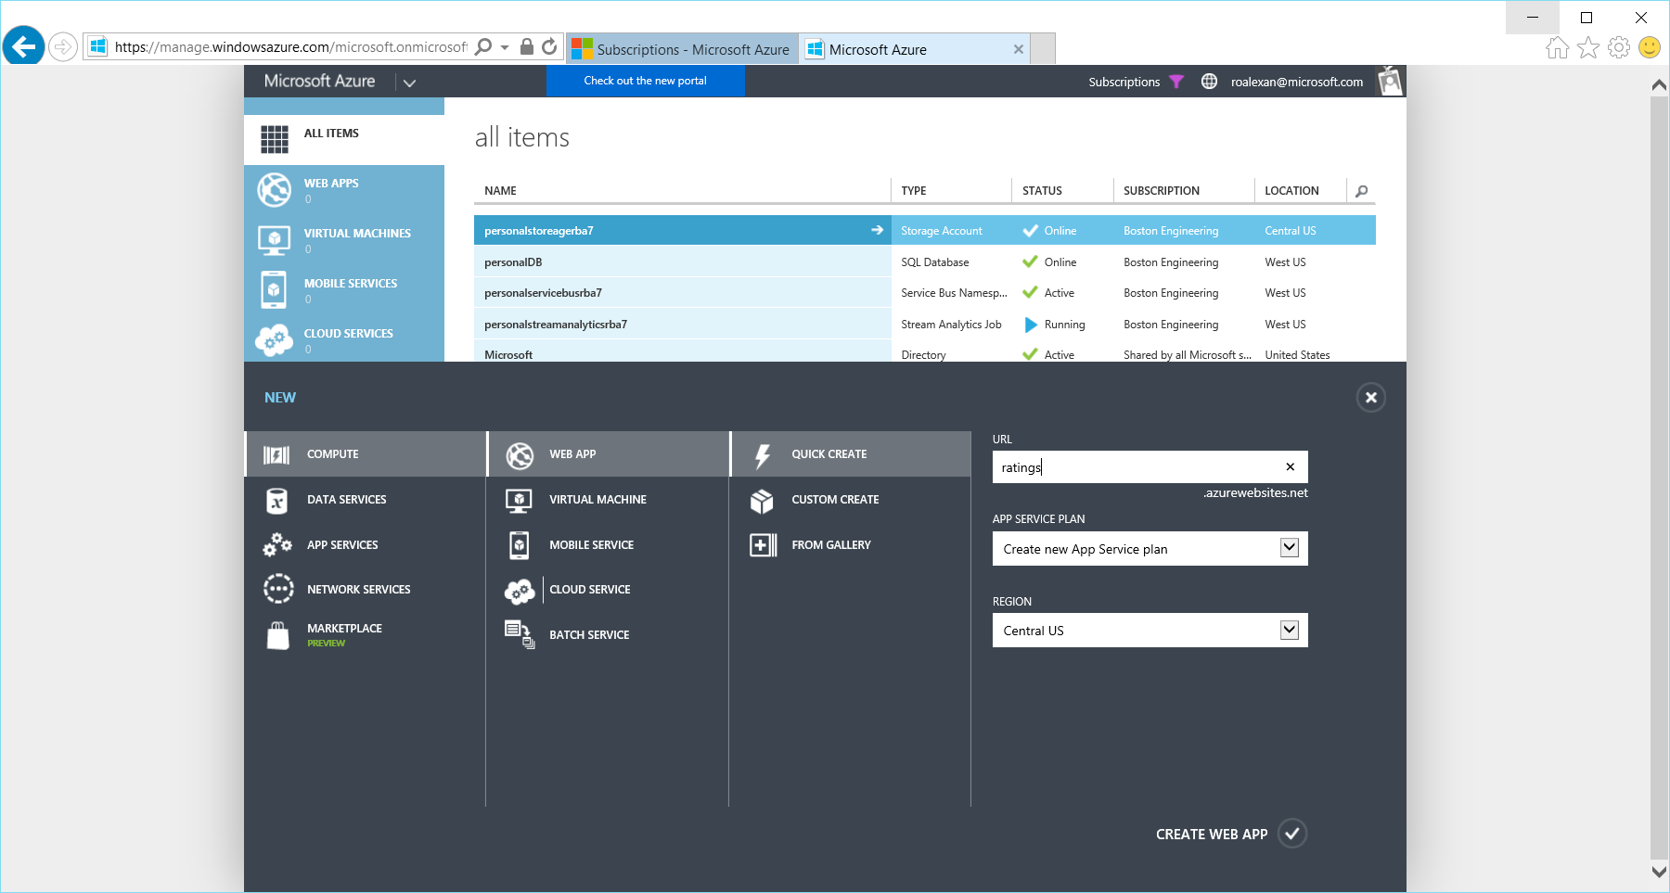

## Analyze

Browse: <https://studio.azureml.net>

Click: Experiments > NEW

Click: Blank Experiment

Expand: Data Input and Output

Drag: Reader: To: Canvas

Select: Data source: Azure SQL Database

Type: Database server name: **personal-rba7.database.windows.net**

Type: Database name: **personalDB**

Type: Server user account name: personaluser

Type: Server user account password: pass@word1

Uncheck: Accept any server certificate (insecure): No # Default

Type: Database query:

select DateTime, EventId, Rating from Ratings

Click: Run

Click: Output port, click: Visualize

# Visualize

Browse: <http://azure.portal.com>

Click: SQL databases, select: personalDB

Click: Open in Power BI

Click: Next

Type: Username: personaluser

Type: Password: pass@word1

Click: Sign in

Click: Datasets: AdventureWorksDW

Expand: AggregateSales

Click: PostalCode, Click: SalesAmount

Click: Bar graph

Click: SalesAmount

Expand: AggregateSales

Drag: To: Axis: Customer Income

Click: Line chart

Expand: AggregateSales

Click: SalesAmount

Click: OrderDate

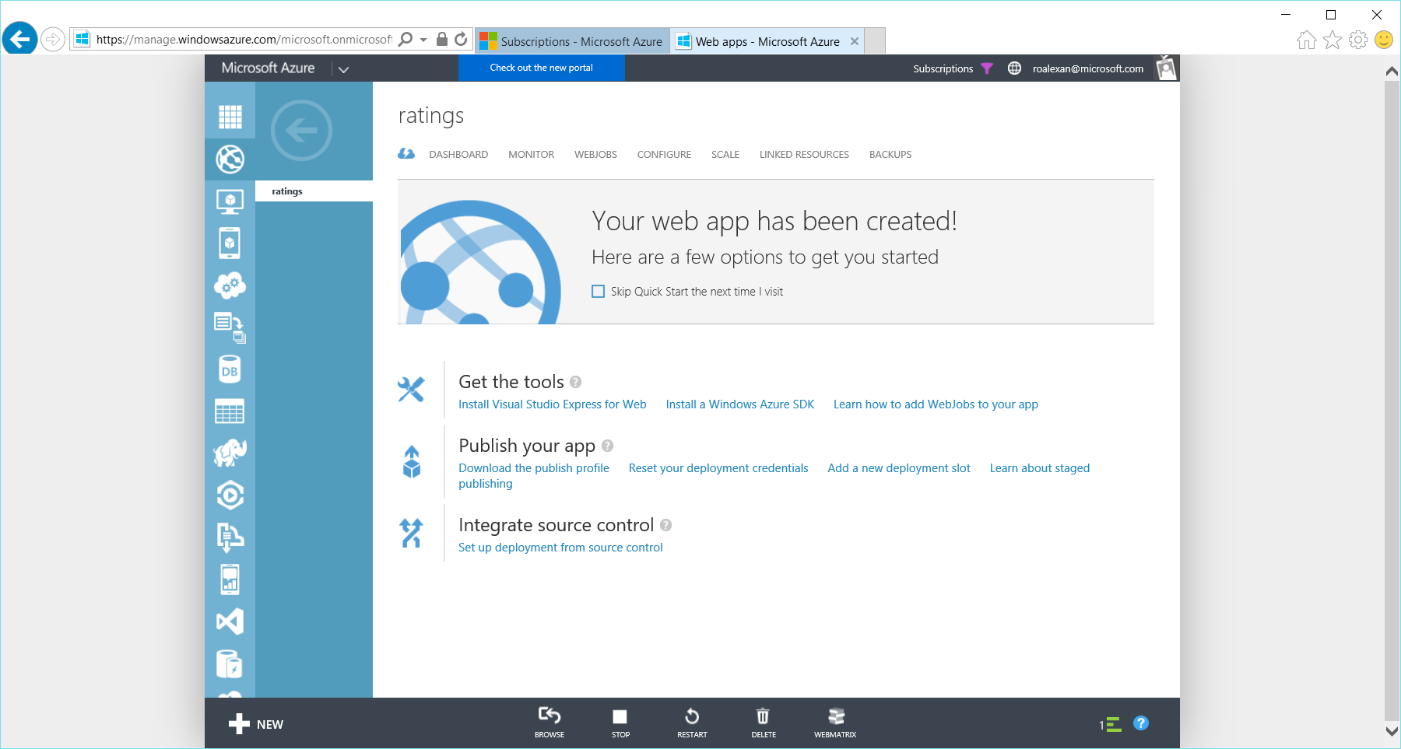

# Undeploy

Login-AzureRmAccount

Select-AzureRmSubscription -SubscriptionID "bc4170f0-cc6e-49d2-ba65-bc00a7a4df6b" # Boston Engineering

#Select-AzureRmSubscription -SubscriptionID "0ca618d2-22a8-413a-96d0-0f1b531129c3" # Boston DS Dev

Remove-AzureRmResourceGroup -Name rbaResourceGroup3

# Errors

PS C:\Users\roalexan> New-AzureRmResourceGroupDeployment -Name rbaDeployment3 -ResourceGroupName rbaResourceGroup3 -TemplateFi

xan\Source\Repos\SolutionArchitects\Collateral\Gallery Samples\SQL Data Warehouse\deploy1.json"

New-AzureRmResourceGroupDeployment : 2:49:20 PM - Resource Microsoft.Sql/servers 'personal-rba3' failed with message 'Server '

is busy with another operation. Please try your operation later.'

At line:1 char:1

+ New-AzureRmResourceGroupDeployment -Name rbaDeployment3 -ResourceGrou ...

+ ~~~~~~~~~~~~~~~~~~~~~~~~~~~~~~~~~~~~~~~~~~~~~~~~~~~~~~~~~~~~~~~~~~~~~

+ CategoryInfo : NotSpecified: (:) [New-AzureRmResourceGroupDeployment], Exception

+ FullyQualifiedErrorId : Microsoft.Azure.Commands.Resources.NewAzureResourceGroupDeploymentCommand

PS C:\Users\roalexan> New-AzureRmResourceGroupDeployment -Name rbaDeployment3 -ResourceGroupName rbaResour

xan\Source\Repos\SolutionArchitects\Collateral\Gallery Samples\SQL Data Warehouse\deploy1.json"

New-AzureRmResourceGroupDeployment : 8:45:56 AM - Resource Microsoft.EventHub/namespaces 'personalserviceb

namespace name is previously used in another project and has been deleted less than one week.'

At line:1 char:1

+ New-AzureRmResourceGroupDeployment -Name rbaDeployment3 -ResourceGrou ...

+ ~~~~~~~~~~~~~~~~~~~~~~~~~~~~~~~~~~~~~~~~~~~~~~~~~~~~~~~~~~~~~~~~~~~~~

+ CategoryInfo : NotSpecified: (:) [New-AzureRmResourceGroupDeployment], Exception

+ FullyQualifiedErrorId : Microsoft.Azure.Commands.Resources.NewAzureResourceGroupDeploymentCommand

New-AzureRmResourceGroupDeployment : 8:45:56 AM - Resource Microsoft.Sql/servers 'personal-rba3' failed wi

'personal-rba3' has already been used.'

At line:1 char:1

+ New-AzureRmResourceGroupDeployment -Name rbaDeployment3 -ResourceGrou ...

+ ~~~~~~~~~~~~~~~~~~~~~~~~~~~~~~~~~~~~~~~~~~~~~~~~~~~~~~~~~~~~~~~~~~~~~

+ CategoryInfo : NotSpecified: (:) [New-AzureRmResourceGroupDeployment], Exception

+ FullyQualifiedErrorId : Microsoft.Azure.Commands.Resources.NewAzureResourceGroupDeploymentCommand

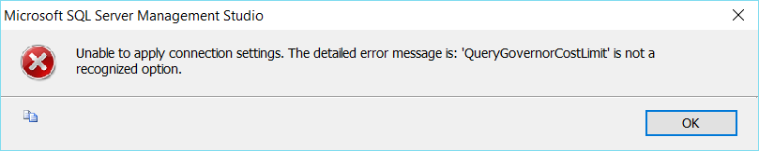

# Questions

* How to stop deployment?
* How to get status of deployment?